California Native Grasslands Association: Learning About California Grasslands
Lesson Title: Carbon Sequestration
Grade level: High school
Lesson Length: 30-50 minutes
Preparation and Materials: Copies of worksheet, pencil
Lesson Goal: Students learn about the process of carbon sequestration, its importance, and how grasslands help to sequester carbon.
Lesson Description: Teacher can incorporate this lesson into sections on environmental issues and climate change, photosynthesis, or nutrient cycling. Students interpret the diagram and read the passage to answer questions. Teacher should guide students to help them understand more difficult concepts and vocabulary. Teacher can lead a discussion or provide a lecture on climate change to stress the importance of carbon sequestration.
Lesson Objectives: Students examine and interpret a conceptual diagram, and answer questions based on their understanding of the diagram and a passage. Students become familiar with vocabulary and application of terms pertaining to carbon cycling. Students learn why carbon sequestration is an important ecosystem service and how grasslands provide this service.
Lesson Background:
Global climate change is a major environmental issue, mainly caused by the burning of fossil fuels, which release carbon dioxide into the atmosphere. Carbon sequestration helps remove carbon from the atmosphere and stores it back in soils. Grassland ecosystems are typically carbon sinks, meaning that they remove more carbon from the atmosphere than they generate. Carbon sequestration by grasslands is particularly important in ameliorating climate change because grasslands cover a large portion of Earth’s land (40.5%), and make up the second largest terrestrial carbon pool after forests (World Research Institute, “Grassland Ecosystems”, 2000). Management and preservation of grasslands and rangelands can assist in climate change mitigation and provide other vital ecosystem services.
Vocabulary Words:
Biomass – tissue from living organisms.
Carbon sequestration – the process of removing carbon from the atmosphere and storing it underground.
Carbon sink – an ecosystem which stores more carbon than it releases into the atmosphere.
Ecosystem service – a naturally occurring environmental process that directly benefits humans.
Photosynthesis – the process by which plants use sunlight to acquire carbon from the atmosphere for growth.
Respiration (aerobic) – a process in which organisms use oxgen in a reaction to produce energy for themselves, creating carbon dioxide as a waste product.
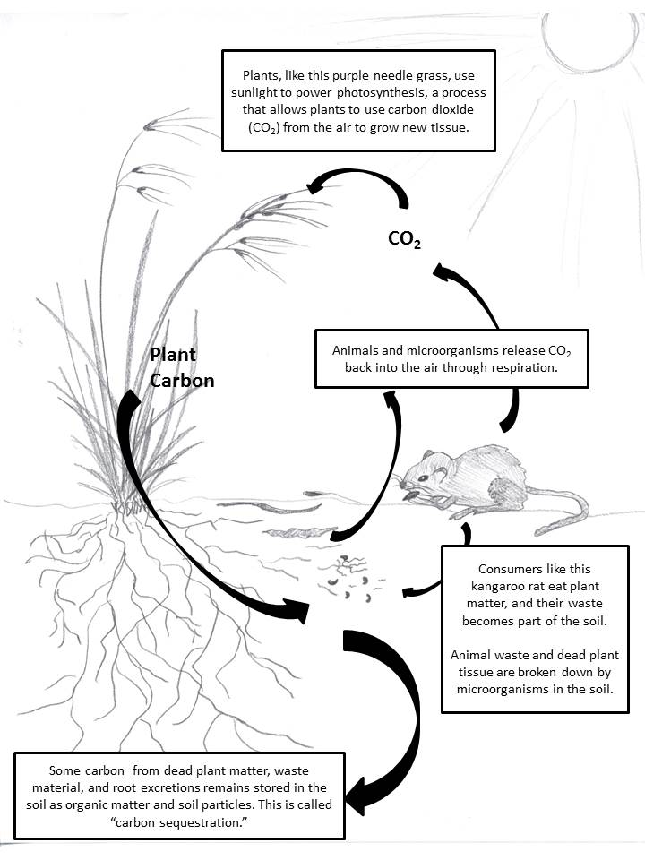
Carbon Sequestration Worksheet Name: __________________________

Carbon Sequestration Worksheet Name: __________________________

Interpret the diagram on the previous page to answer the following questions. Answer the questions 1 and 2 using complete sentences. Fill in the blanks for question 3.
- What is photosynthesis?

- From what source do plants obtain carbon?

- Carbon from plants can either be transformed back into _______ in the atmosphere through a process called___________________ , which is performed by microorganisms and animals, or it can be stored in the_________ in a process known as _____________ __________________.
Read the following passage and answer the questions below:
Some ecosystems absorb more atmospheric carbon than they release, making them “carbon sinks.” Forests are known to be important for sequestering carbon in this way. More recently scientists have learned that grasslands can also act as carbon sinks. In fact, grasslands store the second largest amount of carbon after forests worldwide. In grasslands, there is usually more plant biomass below ground than above ground. Perennial grasses, such as the native California purple needle grass, have roots that can reach 20 feet deep into the ground. These roots deposit carbon in deep soil layers as they die. In addition, grasslands are particularly important for carbon sequestration because they cover a large portion of Earth’s land – about 40%.

Carbon sequestration is what is known as an “ecosystem service,” or a naturally occurring environmental process that directly benefits humans. Fossil fuels such as gas, oil and coal are made from plant material that is millions of years old and buried deep underground. Burning these fuels releases carbon, in the form of carbon dioxide (CO₂), into the atmosphere. Too much carbon dioxide in the atmosphere acts as an insulating “blanket,” and is a major cause of global climate change. Carbon sequestration by grasslands and other ecosystems helps take some carbon out of the atmosphere and put it back into the soil, where some of it will become permanently stored underground once again.
Carbon Sequestration Worksheet Name: __________________________

Using complete sentences, answer the following questions about the passage you read.
- What is a “carbon sink”?

- What is an ecosystem service?

- Why is carbon sequestration important?

- How is carbon sequestration an ecosystem service?

- Why are grasslands important for carbon sequestration?

Carbon Sequestration Worksheet TEACHER’S KEY

- What is photosynthesis?
The process by which plants use sunlight to acquire carbon from the atmosphere for growth.
- From what source do plants get carbon?
Plants acquire carbon dioxide from the atmosphere.
- Carbon from plants can either be transformed back into _CO₂____ in the atmosphere through a process called respiration , which is performed by microorganisms and animals, or it can be stored in the__soil___ in a process known as _carbon__ __sequestration___.
- What is a “carbon sink”?
A carbon sink is an ecosystem which stores more carbon than it releases into the atmosphere.
- What is an ecosystem service?
An ecosystem service is a naturally occurring environmental process that directly benefits humans.
- Why is carbon sequestration important?
Carbon sequestration is important because it removes carbon from the atmosphere, which contributes to global climate change, and stores it in the soil.
- How is carbon sequestration an ecosystem service?
Grasslands naturally sequester carbon from the atmosphere into soil. This benefits humans because reducing climate change is important for many reasons (these can be discussed as part of a complementary lecture or discussion), such as keeping earth’s temperatures within the right range, preventing species extinctions, reducing sea level rise, preventing desertification, maintaining our current land uses such as agriculture and forestry, etc.
- Why are grasslands important for carbon sequestration?
Grasslands store the second largest amount of carbon on land, and cover a large amount of earth’s terrestrial surface.

